# Experiment No. 3 Date:

LAN Network

**Aim:-** To create Local Area Netwok(LAN) in Ubuntu

# Theory:

Apparatus (Components)

1. **Switch**: A network switch is a networking device that connects devices together on a local area network (LAN). It operates at the data link layer (Layer 2) or the network layer (Layer 3) of the OSI Model and uses packet switching to forward data to its destination device based on the MAC address

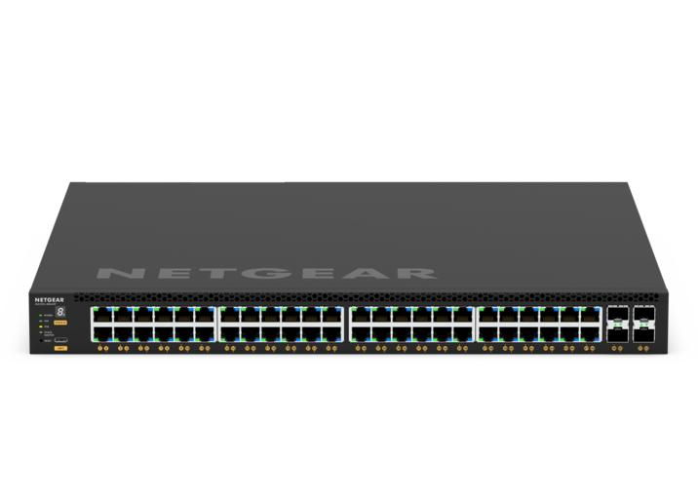

1. **LAN Cable (Cat6)**: Category 6 Ethernet cable, commonly referred to as Cat6 cable, is a type of twisted pair cable used for Ethernet connections. It supports higher bandwidth and is capable of transmitting data at speeds up to 10 gigabits per second (Gbps) over short distances. Cat6 cables are commonly used for connecting devices to network switches, routers, or other networking equipment.

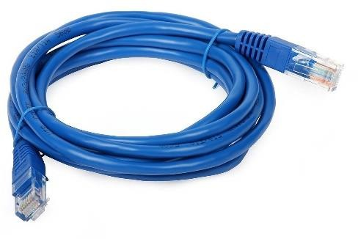

1. **NIC Card**: NIC stands for Network Interface Card. It's also commonly referred to as a network adapter or network interface controller. This is a hardware component installed in a computer or other device that

enables it to connect to a network. The NIC card typically provides a physical connection (such as an Ethernet port or a Wi-Fi adapter) and handles the communication between the device and the network.

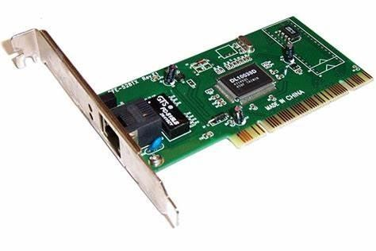

1. **PC (System)**: This refers to a personal computer, which is a general-purpose computing device designed for individual use. In the context of networking, a PC typically refers to a desktop or laptop computer that is equipped with network connectivity capabilities, either through a built-in NIC card or an external network adapter.

Procedure for creating LAN network

## Connect Devices to the Switch:

* + Physically connect each device (such as computers, printers, servers, etc.) to the switch using Ethernet cables (Cat6 cables, for instance).
  + Plug one end of the Ethernet cable into the Ethernet port on the device (e.g., the NIC card port on a computer).
  + Plug the other end of the Ethernet cable into an available Ethernet port on the switch.
  + Ensure a secure connection for each device to the switch.

## Plan your IP Address Scheme:

* + Decide on a range of IP addresses to use within your LAN. This range should be a subset of private IP addresses reserved for LANs, such as those defined in RFC 1918 (e.g., 192.168.x.x, 10.x.x.x, 172.16.x.x - 172.31.x.x).
  + Determine the subnet mask you will use. Commonly used subnet masks for small to medium-sized LANs are /24 (255.255.255.0), which allows for up to 254 hosts per subnet.

## Assign IP Addresses:

* + Assign static IP addresses to devices that require fixed addresses, such as servers, printers, or network devices like switches or routers. Ensure that each device has a unique IP address within the chosen range.
  + For devices that don't need static IP addresses, you can configure DHCP (Dynamic Host Configuration Protocol) on a DHCP server (which can be a router or a dedicated DHCP server). DHCP automatically assigns IP addresses to devices within the defined range.

## Configure Subnet Mask:

* + Apply the chosen subnet mask to all devices within your LAN. This ensures that devices can correctly identify which part of an IP address is the network portion and which part is the host portion.

## Set Up DNS:

* + Choose a DNS server to use for name resolution within your LAN. This could be a public DNS server provided by your ISP or a private DNS server within your network.
  + Configure DNS settings on all devices within your LAN to point to the chosen DNS server. This includes setting the DNS server IP address in the network settings of devices or configuring it via DHCP.

## Configure DNS Records (Optional):

* + If you're hosting services within your LAN, such as a web server or mail server, you may need to create DNS records (A records, CNAME records, etc.) to map hostnames to IP addresses.
  + Configure these DNS records on your DNS server to ensure proper name resolution for devices and services within your LAN.

## Test Connectivity:

* + After configuring IP addresses, subnet masks, and DNS settings, test connectivity between devices within your LAN. Ping various devices using their IP addresses to ensure they can communicate with each other.
  + Test DNS resolution by resolving domain names to IP addresses and vice versa to ensure that DNS is functioning correctly.

## Document the Configuration:

* + Document the IP address assignments, subnet mask, DNS settings, and any other relevant configurations for future reference and troubleshooting.

Procedure for sharing folder:

### Prepare the Folder:

* + Select the folder you want to share on one of the devices within the LAN, such as a computer or a server.
  + Right-click on the folder and select "Properties."
  + In the Properties window, navigate to the "Sharing" tab.

### Share the Folder:

* + Click on the "Advanced Sharing" button.
  + Check the box labeled "Share this folder."
  + Optionally, you can change the share name if desired.
  + Click on the "Permissions" button to set permissions for who can access the shared folder.
  + In the Permissions window, you can add specific users or groups and assign them appropriate permissions (e.g., Read, Read/Write).
  + Click "Apply" and then "OK" to close the Permissions window.

### Configure Share Settings:

* + Back in the Properties window, you can also click on the "Security" tab to set NTFS permissions for the folder if needed.
  + Adjust security settings as necessary and click "Apply" and then "OK" to close the Properties window.

### Access the Shared Folder:

* + On other devices within the LAN, open File Explorer (or equivalent).
  + In the address bar, type "\[hostname or IP address of the device sharing the folder]" and press Enter.
  + You should see the shared folder listed. Double-click to open it and access its contents.

### Authentication (if required):

* + If prompted, enter the appropriate username and password of an account that has access to the shared folder.
  + You may choose to remember credentials for easier access in the future.

### Test Access:

* + Verify that you can access the shared folder and its contents from other devices within the LAN.
  + Copy, modify, or create files within the shared folder to ensure proper permissions and functionality.

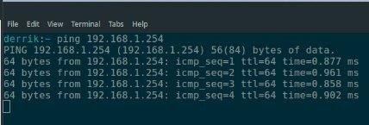

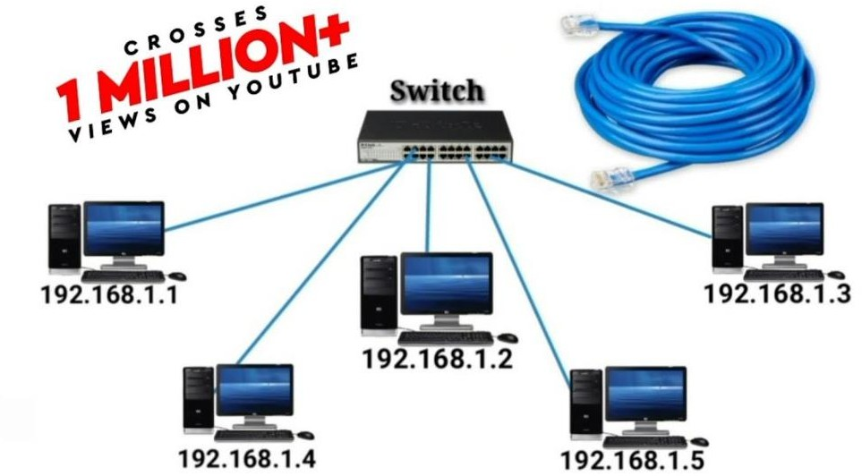

**Conclusion:**

Creation of Local Area Network using switch and LAN Cable in Ubuntu was done successfully.